EGG RACE #2
Rider races a pole at the far end of the arena spoon in hand, dismounts and scoops up an egg, then remounts and returns to the starting line. If the egg is dropped, it must be retrieved.
Sometimes ping pong balls are substituted for eggs. However, ping pong balls are more difficult to handle because of their lighter weight.
Plastic eggs that open can be used; add some weight inside. The contestant with the fastest time with an egg is the winner

RING RACE
This is a timed event of skill and coordination of horse and rider working together.
Course will consist of four stations, two on each side of the arena. At each station there will be a standard at least 7 feet high and with a 4 foot arm attached that can swing out into arena.
Straps or ropes of varying lengths (10 inches to 25 inches) are attached to the end of these arms with a clamp or clothes pin on the other end that will hold a 6‐inch diameter ring made of small half‐inch hose.

Each contestant will be penalized 5 seconds for each ring missed. Pattern can be run either way, and rings picked up with either hand.
A broken pattern is a disqualification and always earns an orange ribbon.
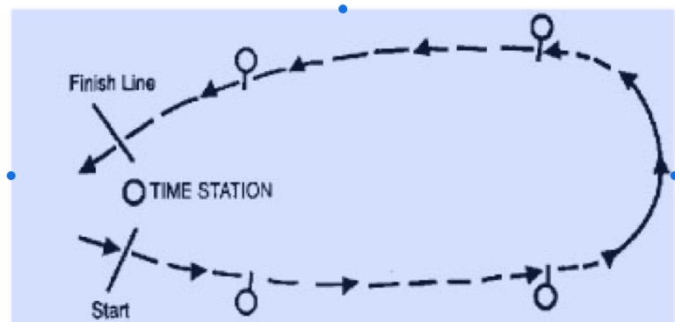

RUN-RIDE-LEAD RACE
Contestants start from one end of the arena and run on foot to get their horses which are either tied or held at the other end of the arena.
Contestants jump onto their horses, ride back to the far end of the arena, dismount, and lead the horses back to the finish line.

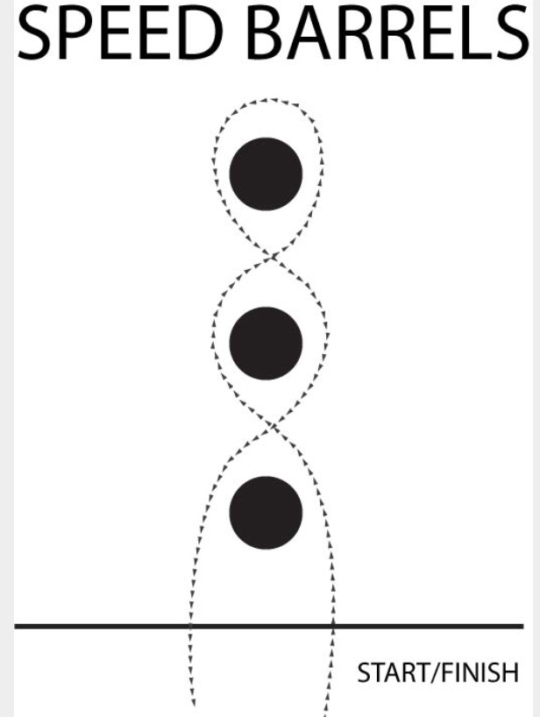
Rider may go either direction

CONE BALL
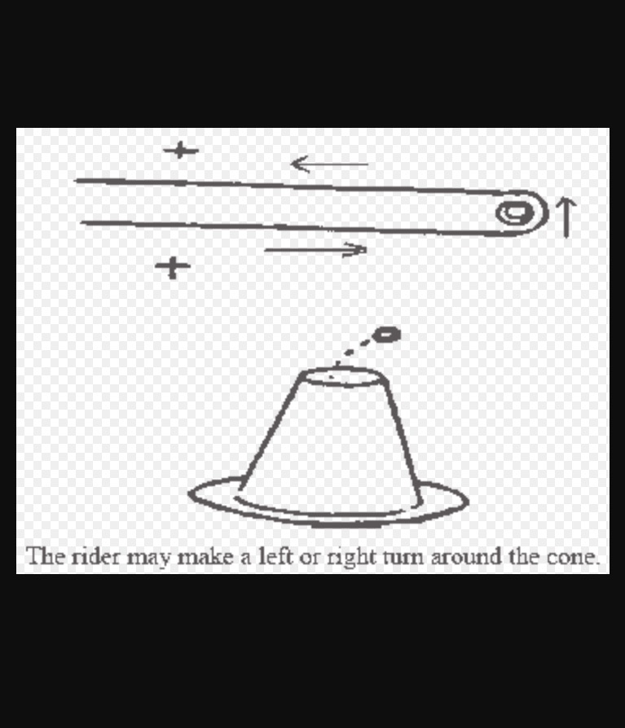
Rider must drop a golf ball in the top of the cone. No time if ball is dropped or barrel knocked over.

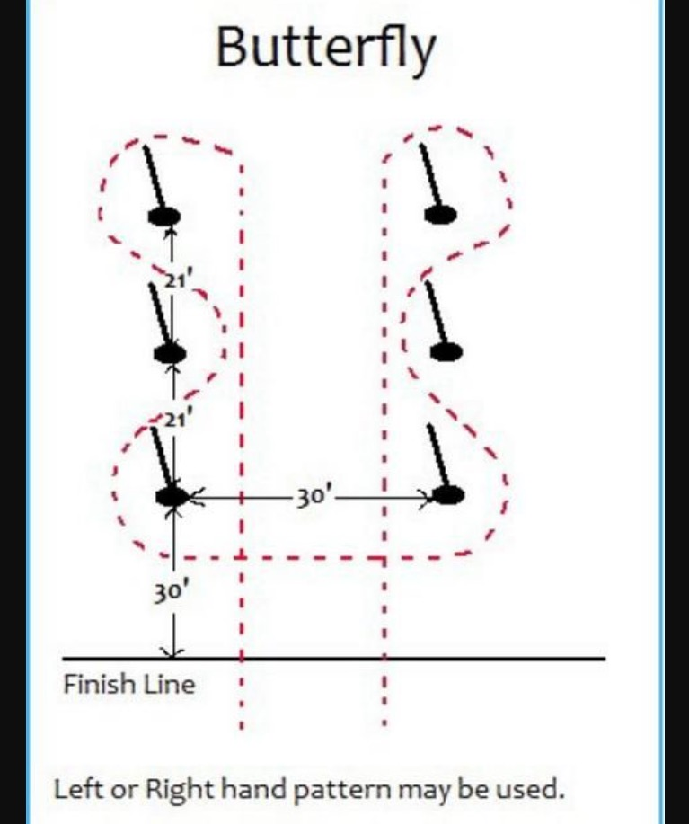

BIG T BARRELS
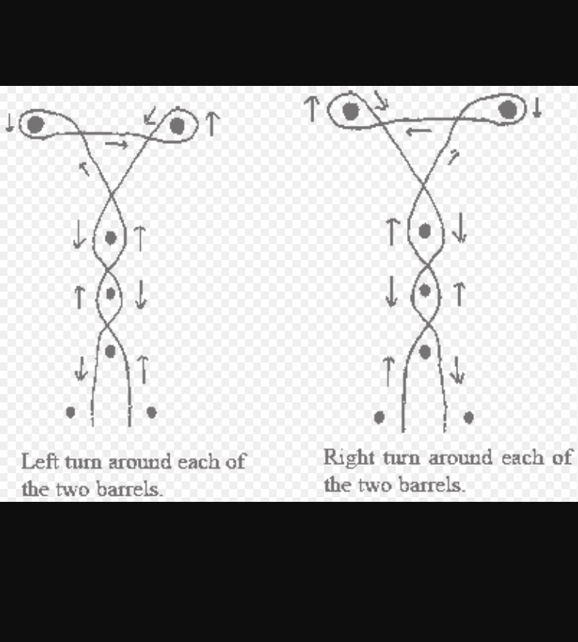

KEYHOLE STAKE RACE
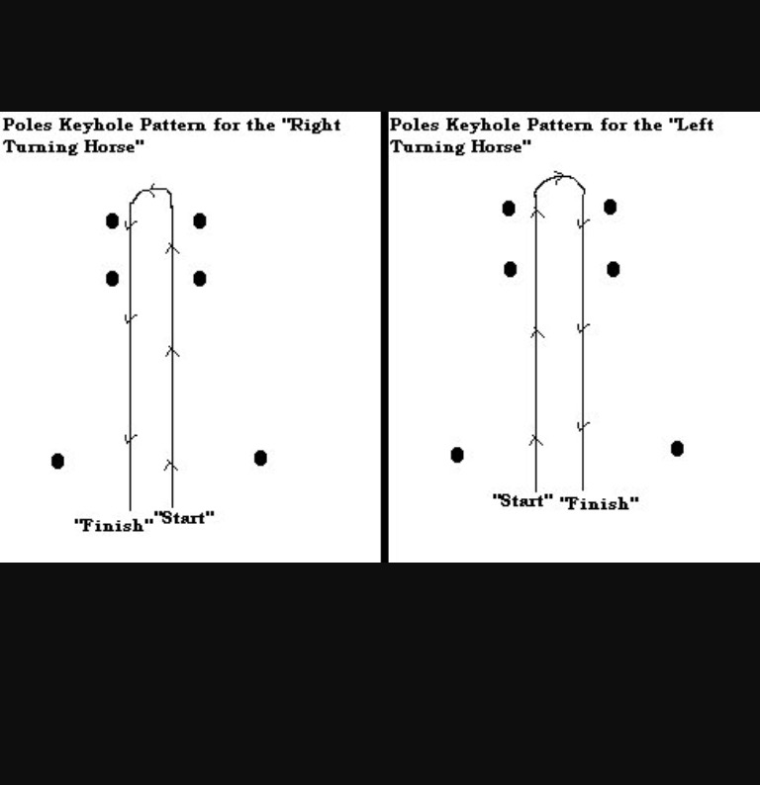
Rider runs through the square of poles, executes a 180 turn and runs back across the timing line.

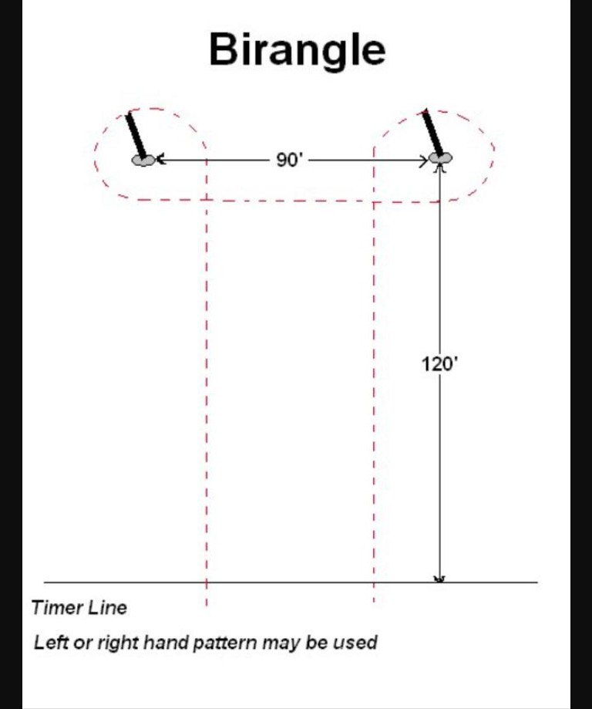
Two left hand turns or two right hand turns.

